Indian Head Tickets and Travel

4163 N. Jackson Road

Indian Head, MD 20640

301-744-4850

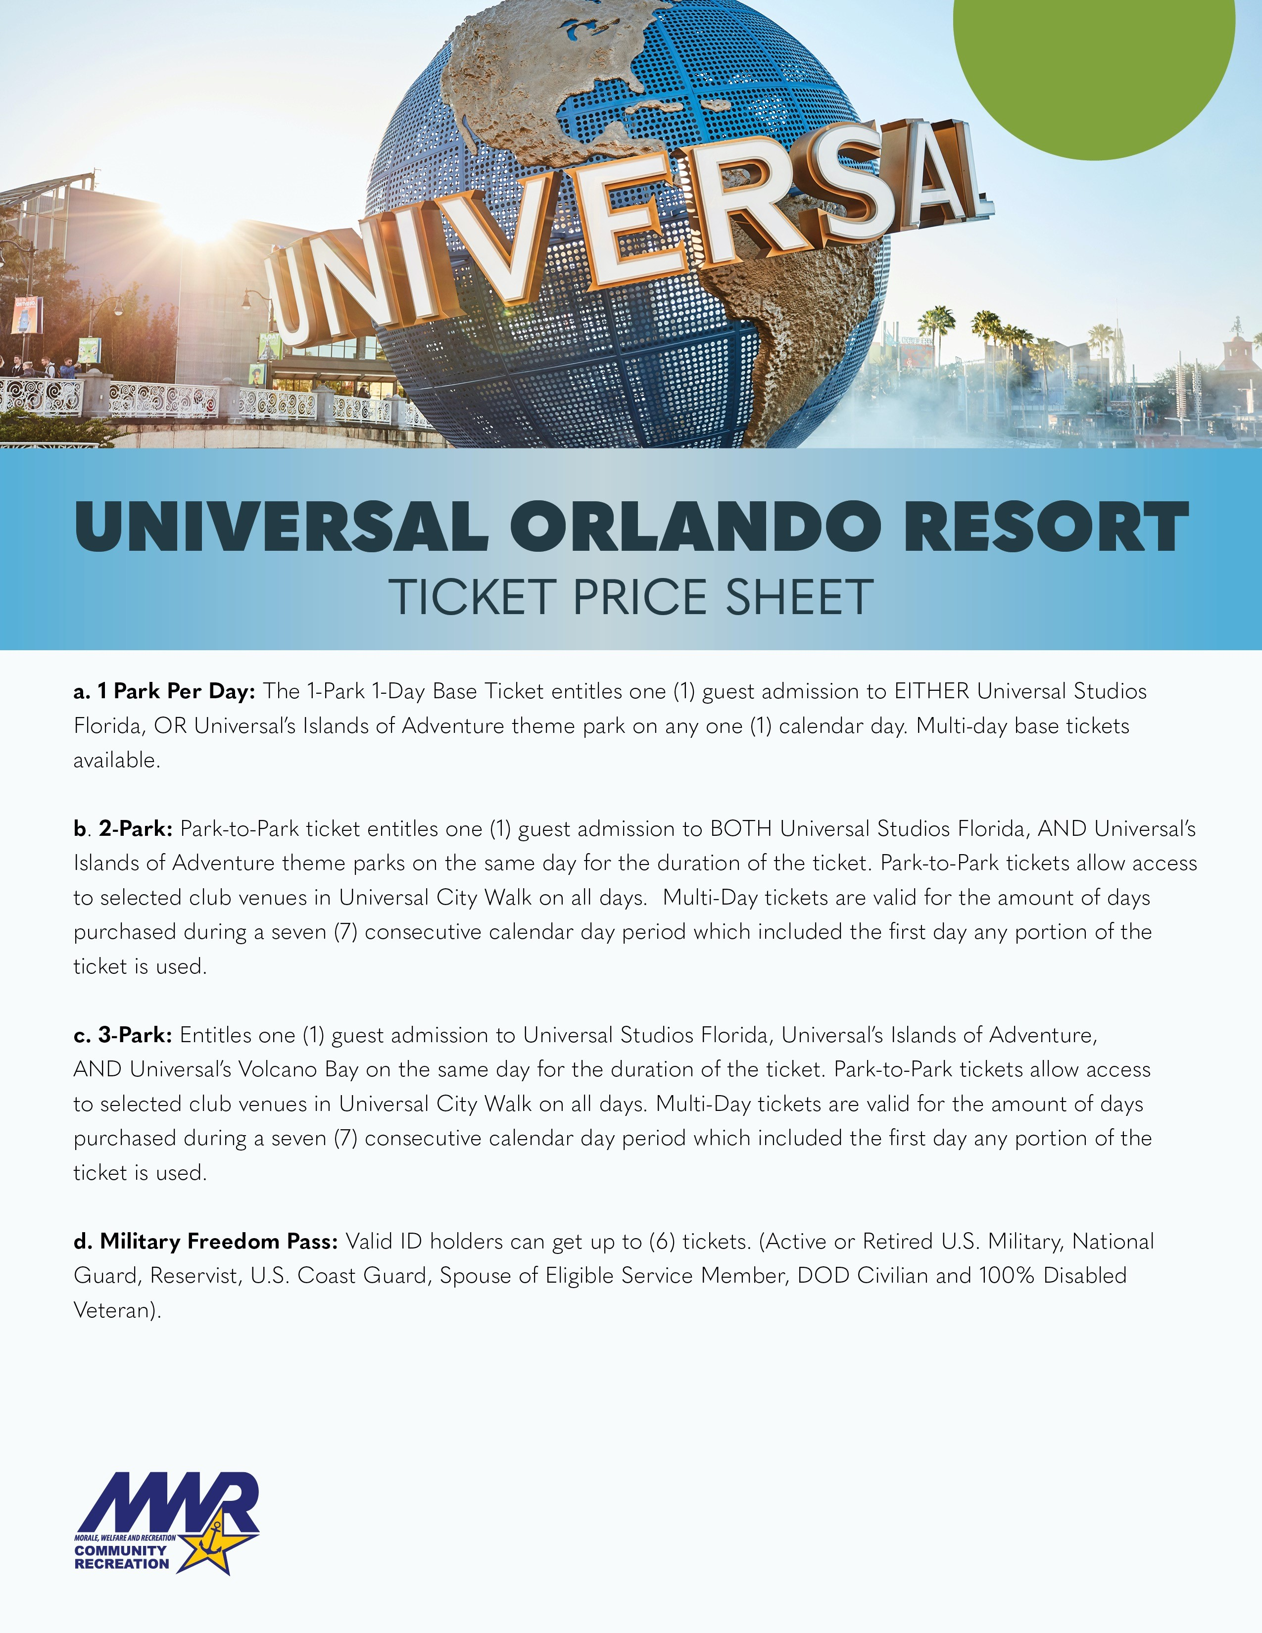

**2025**

•

**•**

**Blockout**

**Dates Apply**

**•12/25/2024**

**–**

**1**

**/**

**2/2025**

**•4/14/2025**

**–**

**4/20/2025**

•

**Ticket expires in full December 19,2025**

**-**

Indian Head Tickets and Travel

4163 N. Jackson Road

Indian Head, MD 20640

301-744-4850

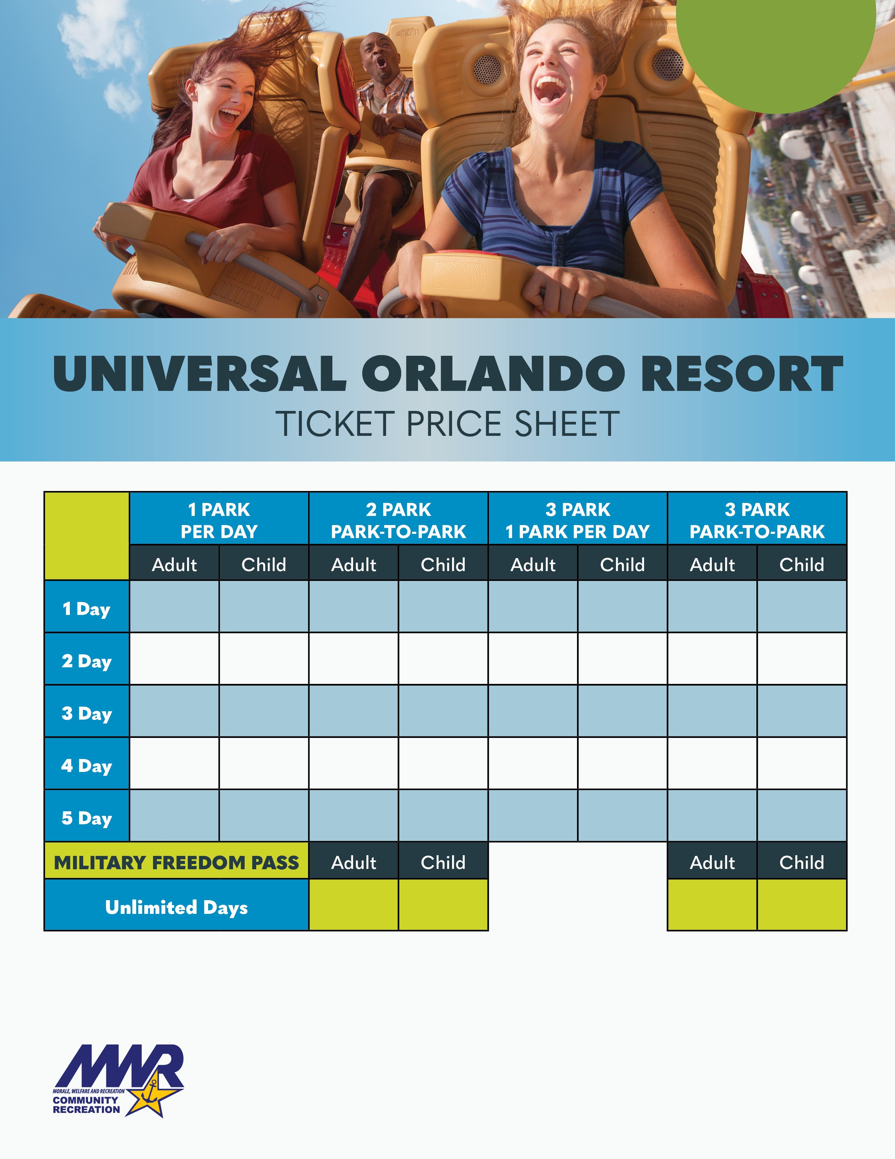

**2025**

•

*No more than six (6) 2*

*-*

*Park and 3*

*-*

*Park Military Freedom Pass Promotional Tickets may be purchased and activated by any*

*Eligible Service Member or spouse. In addition, one of the six (6) tickets purchased must be used by the Eligible Service Mem*

*ber*

*or his/her spouse. Each 2*

*-*

*Park and 3*

*-*

*Park Military Freedom Pass Promotional Ticket must be used by the same person on any*

*and all days.*

•

**Universal elements and all related indicia TM & © 2023 Universal Studios. All rights reserved.**

$127.25

$122.00

$178.50

$173.25

-

-

-

-

$237.00

$227.00

$291.00

$281.00

-

-

$331.00

$321.00

$256.25

$246.25

$311.00

$301.00

$296.75

$285.50

$352.00

$342.25

$261.00

$251.00

$325.00

$316.00

$325.00

$295.75

$375.00

$366.00

$271.00

$261.00

$341.00

$331.00

$331.00

$321.00

$401.00

$391.00

$210.00

$205.00

$245.00

$240.00