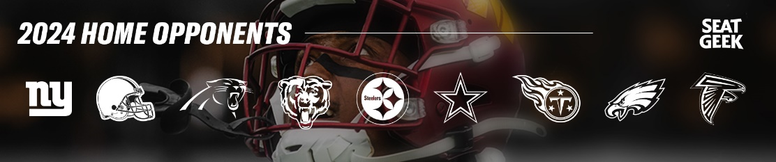
Opponent | Upper Level | Club Level | Lower Level | Number of Tickets
New England Patriots – 8/25 | $65 | $115.50 | $98
New York Giants – 9/15 | $87 | $170.50 | $142
Cleveland Browns – 10/6 | $87 | $170.50 | $142
Carolina Panthers – 10/20 | $76 | $142 | $126.50
Chicago Bears – 10/27 | $109 | $219 | $181.50
Pittsburgh Steelers – 11/10 | $125.50 | $274 | $212.50
Dallas Cowboys – 11/24 | $131 | $274 | $225.50
Tennessee Titans – 12/1 | $76 | $142 | $126.50
Philadelphia Eagles – 12/22 | $131 | $274 | $225.50
Atlanta Falcons – 12/28 or 12/29 (Date TBD) | $76 | $142 | $126.50
PARKING PASSES | X | X | $55.00

Tickets are be prepaid and ordered based on availability. Tickets will be sent to your email address. Please download the Ticketmaster App on your smartphone or computer to download and receive your tickets.

Questions? Please call 301-744-4850 or stop by the ITT desk in the Community Center BLDG 620 any time from 0700-1500 Monday-Friday!

NAME: __________________________________________________________________
PHONE NUMBER: _________________________________________________________

Personal EMAIL: __________________________________________________________

